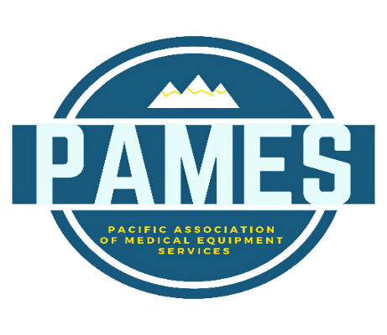 |  | 2026 PAMES Fall Conference  Registration Form  September 21-23, 2026  Embassy Suites – Pioneer Square  Seattle, Washington
REGISTRATION OPTIONS
☐ | Executive Leadership Session Monday Afternoon Session $100.00  Includes all Exec. Sessions, Evening Harbor Cruise and Meal
☐ | DME Conference Registration Tues. & Wed. $250.00/Member-$350.00/Non-Member  Includes all Education, Meals, Vendor Showcases,& Baseball Game
☐ | CRT Education Track (Tuesday Only) $45.00  CEU’s Available. Includes Lunch and Vendor Hall
☐ | Harbor Cruise Only $40.00  Must attend one other session

ATTENDEE INFORMATION
- Register Early by July 31st and Receive a $50.00 Discount
- For Every 3 Attendees From the Same Company, Your 4th is FREE
Name Click or tap here to enter text. |  | Company Click or tap here to enter text.
Phone Number Click or tap here to enter text. |  | Email Click or tap here to enter text.
ADDITIONAL ATTENDEES
Name Click or tap here to enter text. | Email Click or tap here to enter text. |  | Phone Click or tap here to enter text.
Name Click or tap here to enter text. | Email Click or tap here to enter text. |  | Phone Click or tap here to enter text.
Name Click or tap here to enter text. | Email Click or tap here to enter text. |  | Phone Click or tap here to enter text.

PAYMENT INFORMATION
CC# Click or tap here to enter text. |  | Exp Click or tap here to enter text. | CVV Click or tap here to enter text. |  | Zip Code Click or tap here to enter text.
Amount Authorized Click or tap here to enter text. | Signature Click or tap here to enter text. |  |  | Date Click or tap here to enter text.
A 3.5% Service Fee is accessed on all Credit Card transactions. Mail Checks to: PAMES
425 3rd St SW Jamestown, ND 58401
Room block reservations can be made here: PAMES Booking Link until August 20th, 2026

